# Erroneous Interventions into Infrastructure | *The <<< Pirate Girls >>> say...*

### Nancy Mauro-Flude

*The <<< Pirate Girls >>> say...* is a performance installation embracing Wi-Fi meshing assemblage and concrete poetry driven by a software collage of venerable email protocols and up-to-the-minute open AI code for conversational agents (Figures 17.1 and 17.2). The process of making the work incorporates an openness to the fruits of the fiasco of failure when techno-socio-cultural imbroglios of networked communication infrastructure malfunction (Figure 17.3). Rather than tiptoeing around obstructions in fear of a crash, the ethos of failure is embraced, as it carries with it a chance to think otherwise.

*The <<< Pirate Girls >>> say…* enacts interventions in technical infrastructure against its habitual grain through aesthetic and critical actions that extend beyond the practical function of the code. Flagging the value of failure to the so-called common sense of the smooth user experience (UX), the work offers the public a reverse-engineered glimpse of counter-technology. These counter-cultural sites became contested locations of lavish agonistic debate where catastrophe is foregrounded. The intentionality of poetic assemblages of broken chatbot prose trip up capitalist expectations of puritan tropes of literal repair and recovery (Figures 17.3, 17.4, and 17.5). The potency of such failure makes visible the seams and fissures of the concealed undercurrents and schemata of web server infrastructure. To conclude, *The <<< Pirate Girls >>> say...* is an intervention into infrastructure, embracing failure and mayhem, and as a techno-socio-cultural site of rupture. Is there a prototype here to be developed?

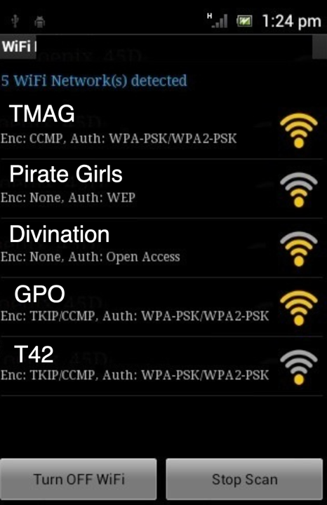

Figure 17.1: WI-FI scan featuring Pirate Girls WI-FI access to captive portal to enter the performance, as viewed from a mobile device. Photo: Mauro-Flude.

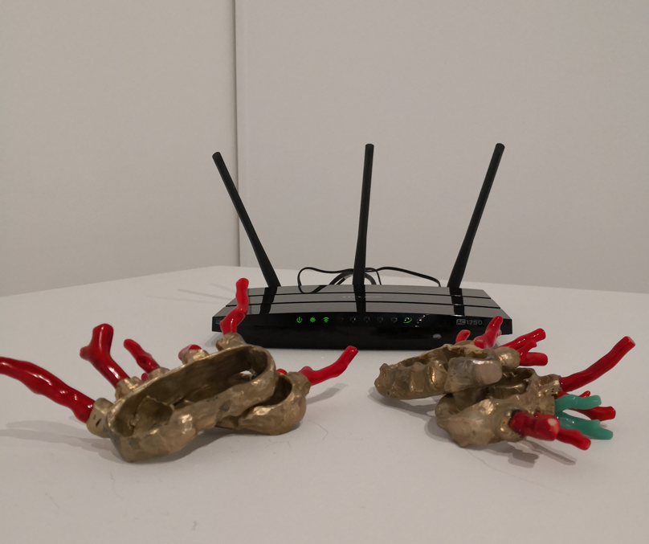

Figure 17.2: *The <<< Pirate Girls >>> say....* Pirate girls ethernet hub, Pyrate Queen Paraphernalia, installation detail, in the exhibition ‘Caught Stealing’ curated by Jamie Tsai at the National Art School Gallery, Sydney[1]. Photo: Mauro-Flude.

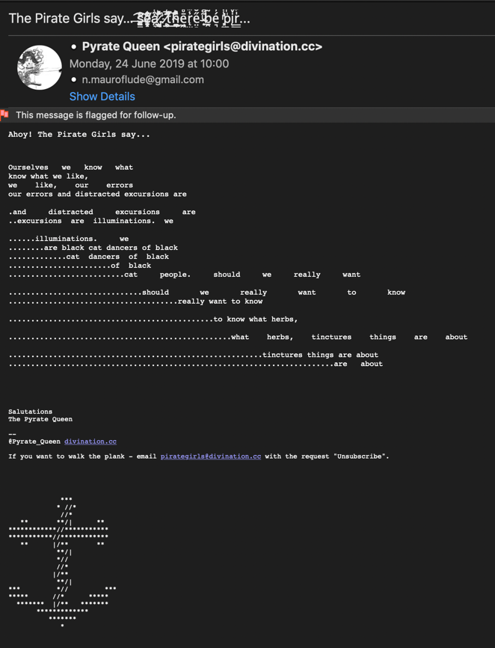

Figure 17.3: Email example of *The Pirate Girls say…* chatbots masquerading as wayward pirate girls in the emails of audiences through inbox repetition, hesitation, gaps and pauses in an email reply, and spatial composition of textstating if you want to receive transmissions and share mutinous sentiments email with the request to subscribe and follow the instructions in your inbox. Photo: Mauro-Flude.

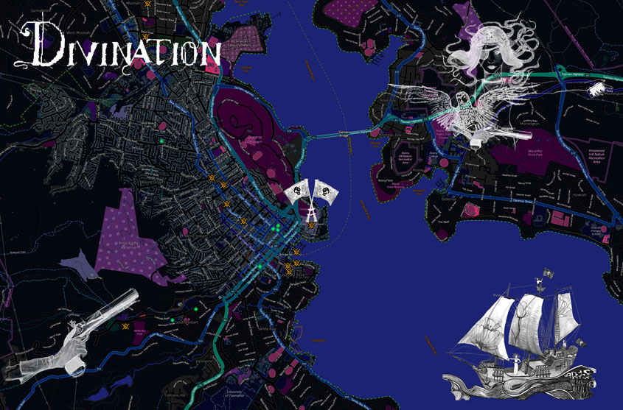

Figure 17.4: A map showing the ‘Pirate Grl’ WIFI ethernet hubs located in popular bars and galleries of the city of Hobart as locations for unsuspecting audiences to join in the erroneous performative exchange. The locations are shown here by the orange skull and crossbones schema for a large-scale performance live code work *Divination: A Romantic Mutiny in a Maelstrom of Data* (2016-9), of which *The <<< Pirate Girls >>> say...* formed a component and premiered in 2016 as a part of Museum of New and Old Art’s Winter festival Dark Mofo. Photo: Mauro-Flude.

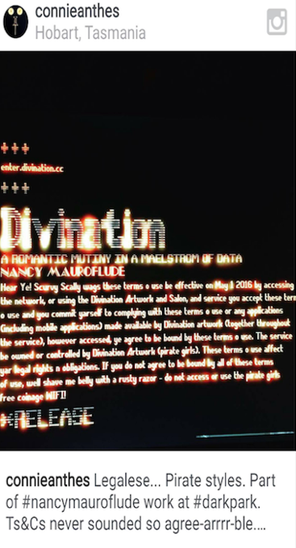

Figure 17.5: Dark Mofo festival audience documentation and Instagram post about Terms and Conditions of *The <<< Pirate Girls >>> say...* .[2] Photo: Mauro-Flude.

## Bibliography

Mauro-Flude, Nancy. *The <<< Pirate Girls >>> say...* (2019-21), http://sister0.org/?ThePirateGirls/.

Mauro-Flude, Nancy. *Divination: A Romantic Mutiny in a Maelstrom of Data* (2016-9), https://divination.cc.

1. Nancy Mauro-Flude, *The <<< Pirate Girls >>> say...* (2019-21), http://sister0.org/?ThePirateGirls/.
2. Nancy Mauro-Flude, *Divination: A Romantic Mutiny in a Maelstrom of Data* (2016-9), https://divination.cc.